Capstone Financial Project

Finale Project Report

Time2GO

Table of Contents

Team Charter 3

Market Research 5

Exclusive Summary 5

Online Travel Market 6

Online Travel Market by Platforms 7

Online Travel Market by Mode of Booking 8

Online Travel Market by Age group 9

Online Travel Market by Region 10

Key Benefits for Stakeholders 10

Key Market Segments 11

‍Brainstorming Document 13

Weighted Scoring Model 14

Business Case for Time2Go 15

Introduction: 15

Business Objective: 15

Current Situation and Problem Statement 15

Critical Assumption and Constraints: 16

Analysis of Options and Recommendation: 16

Preliminary Project Requirements: 16

Budget Estimate and Financial Analysis: 17

Schedule Estimate: 17

Potential Risks: 17

Project Charter 18

Work Breakdown Structure (WBS) 20

WBS Dictionary Entry 21

Gantt chart 22

RACI Chart 23

Milestones List 24

Change Request Methodology 26

Quality Management Plan 28

TOOLS, ENVIRONMENT, AND INTERFACE 28

QUALITY PLANNING 28

Define Project Quality 28

Measure Project Quality 29

QUALITY ASSURANCE 29

Verification 30

Validation 30

Improve Project Quality 31

Requirements Management Plan 32

Overview of the Requirements Management Plan 32

Roles and Responsibilities: 33

Rules and Procedures: 34

Prioritizing Requirements: 34

Risk Register 36

Probability/impact matrix 37

Security Management Plan 38

Step 1: Categorizing the security challenges 38

Step 2: All the security threats should be assessed and controls are given for each one. 38

Step 3: Supplement 39

Step 4: Document 39

Step 5: Assess 39

Step 6: Monitor 39

Stakeholder Management Plan 40

Revisions and Distribution 40

Project Sponsor Approval 41

Stakeholder Management Approach 41

Stakeholder Identification 42

Stakeholder register 44

Stakeholder Management Strategies 45

Control Stakeholder Engagement 46

Communication Management Plan 47

Stakeholder communications requirements: 47

Communications summary: 48

Comments/Guidelines: 48

Escalation procedures for resolving issues: 48

Revision procedures for this document: 49

Glossary of common terminology: 49

# Team Charter

Project Name: Time2go

Project Team Members’ Names and Sign-off:

|  |  |
| --- | --- |
| Name | Date |
| Naazim Changani | January 11th, 2022 |
| Suriya Arivanandhan | January 11th, 2022 |
| Aswini Chacko | January 11th, 2022 |
| Pritesh Piyushbhai | January 11th, 2022 |

**Code of Conduct:** As a project team, we will:

* Follow all instructions with high accuracy
* Collaborate with each other and share ideas
* Work proactively and anticipate potential problems within the project

**Participation:** We will:

* Encourage diversity in team work
* Provide equal opportunity for group members
* Actively participate and attend meetings

**Communication:** We will:

* Find the best way to quickly communicate with each other (Microsoft Teams, Zoom, etc.)
* Have the project manager arrange meetings and inform group members
* Present ideas clearly and concisely

**Problem Solving:** We will:

* Encourage all group members to attempt to solve problems
* Use constructive criticism within the group
* Build on each other’s ideas to solve problems within the project

**Meeting Guidelines:** We will:

* Have one Zoom meeting per week to discuss, share screens, and collaborate on work
* Host additional meetings if needed
* Record meetings to the cloud in case a team member cannot attend

I confirm that this work is my own and I have not copied from internet, other student(s), or any other sources. I followed the individual/group work guidelines specified for completing this assignment. My work is in complete adherence with Conestoga College’s academic integrity policy.

|  |  |  |
| --- | --- | --- |
| ***Name*** | ***Signature*** | ***Date*** |
| Naazim Changani | Naazim Changani | January 11th, 2022 |
| Suriya Arivanandhan | Suriya Arivanandhan | January 11th, 2022 |
| Aswini Chacko | Aswini Chacko | January 11th, 2022 |
| Pritesh Piyushbhai | Pritesh Piyushbhai | January 11th, 2022 |

# Market Research

# 

## Exclusive Summary

The global online travel market is anticipated to witness robust growth in the emerging market of Asia-Pacific. The growth is attributed to increase in disposable income, rise in middle-class segment, and greater penetration of internet facilities. Business travel has also fuelled market growth in Asia-Pacific. Approximately, 90% of corporate travellers in the region own either a smart phone or tablet. More than 50% of these travellers manage their travel through these devices. Companies cater to the needs of travellers through innovative mobile travel apps to gain market share. Apps with various features are being developed to stay connected to travellers throughout their journey and to assist them whenever required. Travel apps offer flexibility to travellers, thus becoming an important differentiating factor for the consumers while choosing a travel company. In addition, customers download hotel and airline apps for quick view and booking status. Thus, proliferation of mobile usage and innovative mobile travel apps are expected to foster the growth of the online travel market in the future.

The global online travel market size was valued at $354.2 billion in 2020, and is estimated to reach $1,835.6 billion by 2031, registering a CAGR of 14.8% from 2022 to 2031.

The COVID-19 pandemic has had a significant impact on the online travel market, due to the travel restriction across the globe in an attempt to prevent the pandemic spread. Online travel has been negatively affected, owing to restrictions on interstate and local traveling, hotel visits, trade fairs, and cultural events visits.

Online travel providers aim to ease travel planning and bookings for travellers. The online travel industry is being pushed by quick and easy flight and hotel bookings, an increase in customer trust in online payment, and the option to compare numerous available travel alternatives. Market players are extensively offering travel services through mobile websites and apps, as it is one of the most preferred mediums of travel bookings, particularly among the young professionals.



The emergence of internet has led to intense exposure of people to social media sites. People first browse through websites, gather detailed information, and review the required product or service before making a purchase. In addition, social media such as Facebook, Twitter, and travel blogs have become a common medium for people to discuss travel plans. Social media acts as a platform for online travel service providers to advertise their services and special offers for online bookings garnering the online travel market growth during the forecast period.

## Online Travel Market

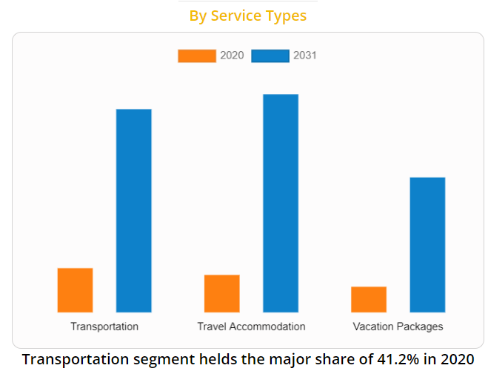

Social and political disturbances affect the travel & tourism industry in specific regions. Customers tend to avoid these conflict prone areas even if they get travel services at affordable prices. Government of several nations have also declared instructions for travellers to refrain from traveling to countries affected with epidemics or social/political unrest. This, limits the scope of online travel booking to those countries thereby affecting the sales of the online travel market.

The online travel market segmented into service type, platforms, mode of booking, age group, and region. On the basis of service type, the market is categorized into transportation, travel accommodation, and vacation packages. By platform, it is segmented into mobile and desktop. On the basis of mode of booking, it is segmented into online travel agencies (OTAs) and direct travel suppliers. On the basis of age group, market is segmented into ¬22-31 years¬ 32-43 years¬ 44-56 years¬ and >56 years. Region-wise, it is analysed across North America (the U.S., Canada, and Mexico), Europe (Germany, France, UK, Italy, Spain, and rest of Europe), Asia-Pacific (China, India, Japan, Australia, South Korea, and rest of Asia-Pacific), and LAMEA (Brazil, Argentina, UAE, Saudi Arabia, South Africa, and rest of LAMEA).

Online Travel Market by Platforms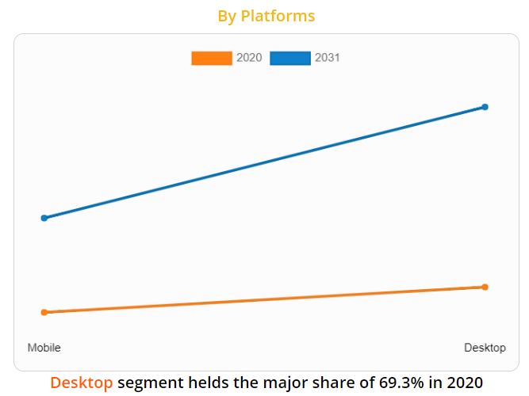

According to the online travel market trends, on the basis of service types, the travel accommodation segment was the considerable contributor to the market, with $123.7 billion in 2020, and is estimated to reach $719.5 billion by 2031, at a CAGR of 16.0% during the forecast period. Travelers are increasingly being offered a diverse range of hotel options at reasonable costs by market players. Customers compare accommodation options at several websites to get the best affordable deal. Travelers choose specialized online accommodation providers such as Airbnb, Inc. and OYO Rooms because they provide a wide range of lodging alternatives. Thus, above mentioned factors are attributable for the growth of the market through travel accommodation segment.

According to the platforms, the mobile segment was the significant contributor to the market, and is estimated to reach $617.9 billion by 2031, at a CAGR of 15.8% during the forecast period. Increase in usage of mobile and innovative mobile travel apps majorly attribute for the growth of the market through mobile segment. Technology has changed the way people communicate and travel across the globe. With evolving technology and increase in use of mobiles, easy and efficient methods are being developed to make traveling easy and comfortable, thus increasing the growth of travel industry. Mobile travel apps are gradually gaining pace in the market and are preferred by travellers to make their travel arrangements. Thus, increase in usage of the smart phones and growth in digital literacy is likely to proliferate the growth of the online travel market.

## Online Travel Market by Mode of Booking

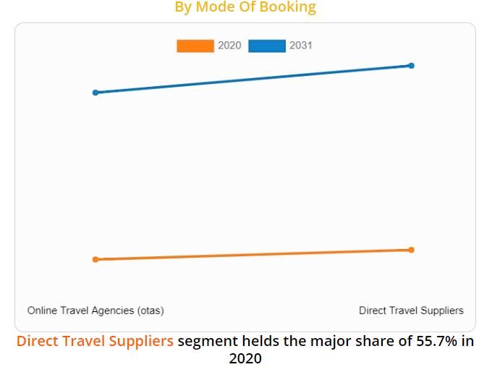

On the basis of mode of booking, the direct travel suppliers’ segment was accounted for major share in global online travel market and is expected to sustain its share throughout the forecast period. Direct travel suppliers are the major revenue contributors in the product market. However, this segment witnesses an increase in threat from the growing online travel agencies (OTAs) market share. To remain competitive, airlines such as Lufthansa AG choose to circumvent OTAs by charging additional fees for bookings made through the OTAs. The online travel industry through direct travel suppliers is developing at a slower rate, because customers are constantly using OTA platforms.

According to the online travel market analysis, on the basis of age group, the 22-31 Years segment was the considerable contributor to the market, with $102.0 billion in 2020, and is estimated to reach $539.2 billion by 2031, at a CAGR of 15.0% during the forecast period. The age group of 22–31 years comprises the young population, which are the early starters in their professional career. When compared to travellers in the older age groups, these travellers are more likely to spend more money on travel and visit new places. These travellers have changed the travel business because of their extensive use of technology, Smartphones and other mobile devices are largely preferred to make travel arrangements. Furthermore, social media platforms are utilized to evaluate various travel service providers, locations, modes of transportation, and lodging. As a result, the industry is experiencing strong growth in the 22–31-year age group sector.

## Online Travel Market by Age group

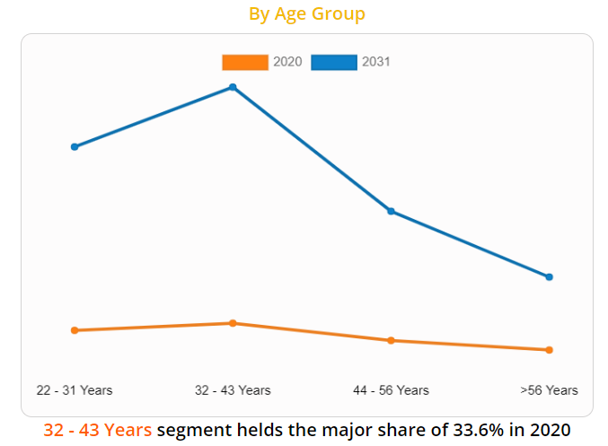

According to the online travel market opportunities, region wise, Asia-pacific gained significant online travel market share and is expected to sustain its share throughout online travel market forecast period. It possesses the highest growth potential in the online travel market, India and China being the most lucrative markets. The growth is attributed to the increase in disposable income, rise in middle-class segment, and greater penetration of internet facilities. Ctrip is the leading player in online travel market in China, whereas MakeMyTrip, Yatra, and Clear trip are the major online travel agencies (OTA) in India.

The players operating in the global online travel industry have adopted various developmental strategies to expand their market share, increase profitability, and remain competitive in the market. The key players profiled in this report include Expedia Group, Inc., Ebury Partners UK Ltd, Fare portal Inc., Hostelworld.com Limited, Hurb Co S/A, HRS, MakeMyTrip Ltd., Oracle Corporation, Priceline (Booking Holdings Inc.), SABS Travel Technologies, Tavisca Solutions Pvt. Ltd., Thomas Cook India Ltd., travelomatix.com, Trip.com Group, TripAdvisor, Inc., and WEX Inc.

## Online Travel Market by Region

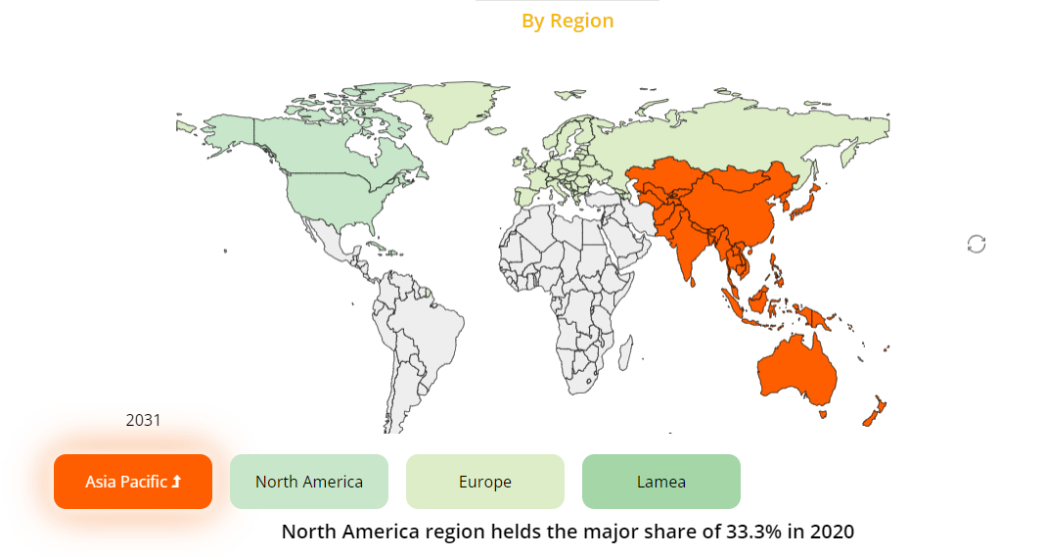

## Key Benefits for Stakeholders

* The report provides a quantitative analysis of the current trends, estimations, and dynamics of the market size from 2020-2031 to identify the prevailing opportunities.
* Porter’s five forces analysis highlights the potency of buyers and suppliers to enable stakeholders to make profit-oriented business decisions and strengthen their supplier–buyer network.
* In-depth analysis and the market size and segmentation assist to determine the prevailing market opportunities.
* The major countries in each region are mapped according to their revenue contribution to the market.
* The market player positioning segment facilitates benchmarking and provides a clear understanding of the present position of the market players in the online travel market.

## Key Market Segments

* **By Service types**
  + Transportation
  + Travel Accommodation
  + Vacation Packages
* **By Platforms**
  + Mobile
  + Desktop
* **By Mode of booking**
  + Online Travel Agencies (OTAs)
  + Direct Travel Suppliers
* **By Age Group**
  + 22-31 Years
  + 32-43 Years
  + 44-56 Years
  + >56 Years
* **By Region**
  + North America
    - U.S.
    - Canada
    - Mexico
  + Europe
    - Germany
    - France
    - UK
    - Italy
    - Spain
    - Rest of Europe
  + Asia-Pacific
    - China
    - India
    - Japan
    - Australia
    - South Korea
    - Rest of Asia-Pacific
  + LAMEA
    - Brazil
    - Argentina
    - UAE
    - Saudi Arabia
    - South Africa
    - Rest of LAMEA

**Other players in the value chain include:**

* Alibaba Group
* Elong, Inc.
* TUI Group
* Tuniu Corporation
* Air Gorilla, LLC
* Hays Travel limited
* Airbnb, Inc.
* Yatra Online Private Limited, India

# ‍Brainstorming Document

**Title:**Financial Technology securities project

**Date:**January 14 2022

**Facilitator:**Naazim Changani.

**Participants:**Suriya, Aswini, Pritesh.

‍**Goals / Issues:** Creating a mobile application that provides a solution to loopholes/gap in the financial industry, while keeping monetization in mind also encrypting the application for privacy and storage security.

‍**Suggestions / Ideas:**

**Idea 1:** Scan and Shop app

* AI tells the details about the product, what ingredients are in the product and the expiration date.
* Target shopping centre already developed a similar product that is used in their stores and franchise.

**Idea 2:** NFT virtual bidding app

* The mobile application will have customers select which NFT they’re interested in and when its price declines or surges the customers will be notified.
* NFT’s is trending now, however there is no future plans for the application if NFT’s are obsolete the mobile application is useless.

**Idea 2:** Travel application using metaverse

* The mobile application will create a realistic image of travel and tourism spots for customers to preview the location before visiting the place and payments can be make thought crypto-currency.
* The whole application is depended on Facebooks Metaverse, if the application fails it will impact the mobile application and also the whole project idea of realistic images.

**‍**

**‍Final Decision:**Travel application using Metaverse is what the team decided as its mobile application because it’s something new and never done till date.

# Weighted Scoring Model

|  |  |  |  |  |  |
| --- | --- | --- | --- | --- | --- |
| **Criteria** | **Weight** | **P1** | **P2** | **P3** | **P4** |
| Uniqueness | 20% | 92 | 80 | 50 | 50 |
| Cost effective | 10% | 90 | 63 | 75 | 40 |
| Ease of development | 10% | 84 | 56 | 76 | 45 |
| Scope | 20% | 80 | 80 | 42 | 60 |
| Technology | 25% | 87 | 70 | 75 | 60 |
| Time | 15% | 75 | 45 | 57 | 46 |
| Weighted score | 100% | 84.8 | 68.15 | 60.8 | 52.4 |

P1 - Design a virtual travel app by metaverse and accept the payments for bookings on the app using cryptocurrency.

P2 - An app to facilitate acceptance of cryptocurrency from the customers and paying the ecommerce platform through cash on behalf of customer.

P3 - Include feature of sending notification of price hike in crypto currency wallet.

P4 - App that has a map for locating stores that accepts crypto currency.

# Business Case for Time2Go

15-04-2022

|  |
| --- |
| Introduction: Time2Go is a mobile application that provides customers a chance to travel across the world just by siting at a place. Time2Go travel application is a travel booking mobile application using metaverse. It is future of travel and tourism. Application is set to take the advantages of advanced technology. We foresee we will be a pioneer in establishing this technology in this industry. Travel restrictions during pandemic has brought us this idea of tourism through virtual reality. |
| Business Objective: Time2Go travel app will make international travel affordable for everyone. Business aims to enter the market of travel industry and make use of technology as an opportunity to reach a wider customer base. We believe that our application adapts people centered approach. People centered approach will make this business reach out to all categories of people thus obtaining a huge range of customers. Retaining customers by providing the best services. Application also has a payment module integrated where it accepts bitcoins as payment along with the other payment modes. The business targets young and old at the same time. |
| Current Situation and Problem Statement**:**  Problem statement: Travel industry was greatly affected at the time of pandemic. An alternative to physical travel will be virtual reality. At present there are no applications that uses metaverse to provide tourism. And there is no alternative to expensive international tours.  Solution: Mobile application that helps the customers have the same experience as travelling physically to a place at an affordable price. Also encourages customers who pays through cryptocurrency to encourage the futuristic technology. Time2Go application provides services and products will initially include pre-arranged virtual world tours. |
| Critical Assumption and Constraints: Application is expected to revolutionize the way people see travelling. Project assumes that the travelers will encourage the idea of travelling siting at a place. Time2Go is an innovative project, it bares with it all the risk of a startup. Application uses metaverse and may lead to new issues in security and privacy that was unforeseen, since is a novel approach. A compromise on any privacy can be a doom to the project.  Timeframe of the project is short than the required but is expected to finish by the delivery time. |
| Analysis of Options and Recommendation:  Option 1: Travel application for booking – Booking a tour and going in person to the place will be really expensive and may not be possible in difficult times.  Option 2: Travel application use perforce to build VR – Expensive to build.  Option 3: Travel application using metaverse - Metaverse has applied great focus on VR experiences, 3-D mapping and hardware. |
| Preliminary Project Requirements:   Project plan document.  Management and project team for developing the project.  Funds for the project.  Software and hardware required to build application. |
| Budget Estimate and Financial Analysis: Item Amount  Hardware 35000  Software 40000  Salary 240000  miscellaneous 22600  *Total Cost 3,37,600* |
| Schedule Estimate:  |  |  | | --- | --- | | Task Name | Duration | | **Time2Go application using Metaverse** | **83 days** | | Initiation | 11 days | | Planning | 19 days | | Execute | 40 days | | Monitor & Control | 16 days | | Closing | 1 day | |
| Potential Risks:   * Fail to establish collaboration with potential participants. * Fail to meet the deadline * Compromise the security * Project goes overbudget. * Dependency on tasks from third party may dely. * Project failing to meet the scope. |
| Exhibits:  Exhibit A: Financial Analysis |

# Project Charter

|  |  |  |  |
| --- | --- | --- | --- |
| **Project Title**: Time2Go | | | |
| **Project Start Date:** January 14, 2022 **Projected Finish Date:** April 21, 2021 | | | |
| **Budget Information:** $320,000 | | | |
| **Project Manager:** Naazim Changani | | | |
| **Project Objectives:**   1. To develop a mobile application that has customer interaction using crypto-currency as payment method and increasing productivity. 2. To create an application which help to develop more interaction with Metaverse to preview places and location with realistic images and surroundings. 3. To develop a solution which helps customer view what they buy before the final decision. | | | |
| **Success Criteria:**   1. To develop guidelines and template for the functioning of Metaverse type of events. 2. Accept money provided by the potential investors. 3. Developing mobile application for motivating both the customers and the tourism locations. 4. Create a systematic way to get back a percentage of the donation and profit come back to the Time2Go. 5. Making an online version which include the contestant’s video and the live reactions of the Travel destinations. | | | |
| **Approach:**   1. Assigning work to every person in an efficient manner. 2. Conducting meeting in a timely manner to make sure everything is going according to the plan and to find out the progress. 3. Analyzing the plan with the help of developed software’s. | | | |
| **Roles and Responsibilities** | | | |
| ***Name and Signature*** | ***Role*** | ***Position*** | ***Contact Information*** |
| Robert | Project Sponsor | CEO | prjk963@gmail.com |
| Adam | Project Manager | Manager | adamh@gmail.com |
| Bobby | Team Member | Account executive | bobby86@gmail.com |
| Ashok | Team Member | Quality Assurance Tester | ashok123@gmail.com |
| Kim | Team Member | Programmer | Kim6789@gmail.com |
| Alfreda | Team Member | Web Graphic Designer | Alfreda456@gmail.com |
|  | | | |
| **Comments:**  Hope this project charter will help in the proper functioning of the project. | | | |

# Work Breakdown Structure (WBS)

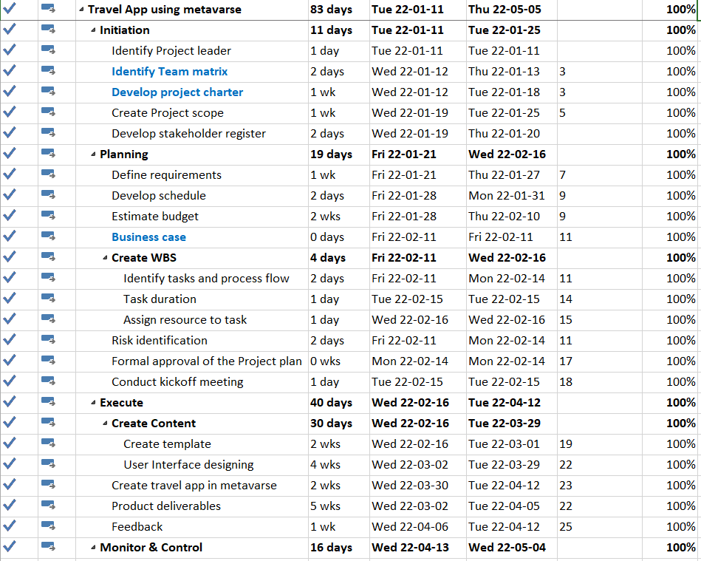

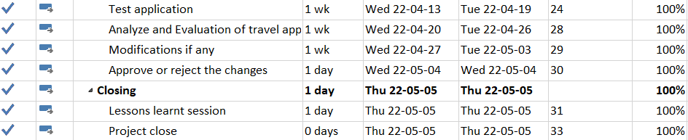

# WBS Dictionary Entry

**14-04-2022**

|  |  |
| --- | --- |
| **WBS Dictionary** | **Details** |
| **Initiation** |  |
| Identify Project leader | Selection of project leader for the project |
| Identify Team matrix | Assigning team members and defining roles and responsibility |
| Develop project charter | Identifies key stakeholders and define the authority of team members |
| Create Project scope | Defines the scope of the projects |
| Business case | Documents the justification undertaking a project |
| Develop stakeholder register | Lists all who are involved or affects the project |
| **Planning** |  |
| Define requirements | Lists all the features, functions, and tasks that need to be completed |
| Develop schedule | Draws the time required to complete each task and the end of the project |
| Estimate budget | Clear breakdown of cost for each task and estimation of total cost of the project |
| Identify tasks and process flow | Lists the process flow of the project |
| Assign resource | As per the requirement, resources are assigned to each process |
| Risk identification | Identify the risk that may occur during the project |
| Formal approval of the Project plan | Sponsor of the project approves the plan |
| Conduct kickoff meeting | Kickoff meeting is the first meeting with the stakeholders of the project |
| **Execute** |  |
| Create Content | Preparation of the content that goes to the Time2Go mobile application |
| Create template | Design each template for each page of the application |
| User Interface designing | Design how the Time2Go app look to the users |
| Create travel app in metaverse | Coding and implementing the application |
| Product deliverables | Final product |
| Feedback | Feedback from the stakeholders of the project |
| **Monitor & Control** |  |
| Test application | Time2Go travel application is tested and checked for performance |
| Analyze and Evaluation of travel app | Evaluate the application |
| Approve or reject the changes | Lists the changes that was suggested after testing |
| **Close** |  |

**Project Name: Time2Go**

# Gantt chart

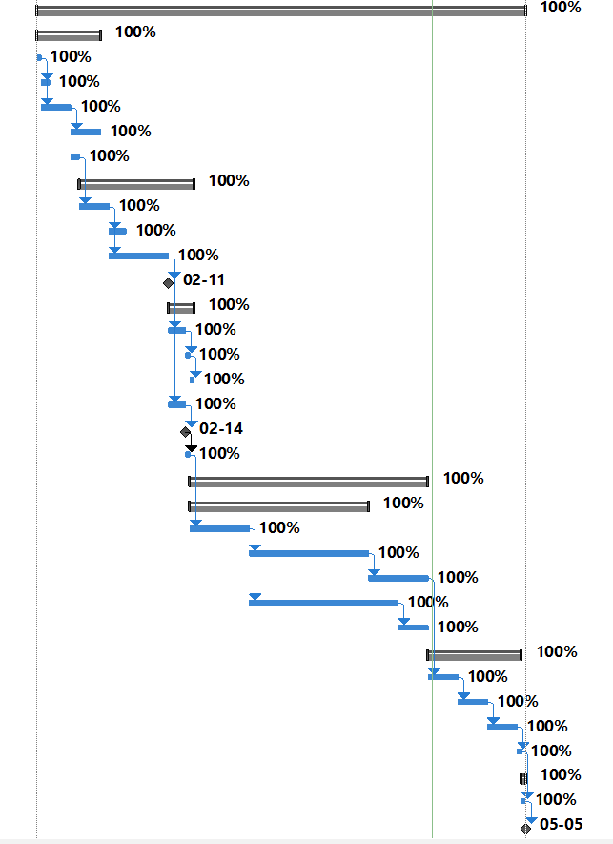

# RACI Chart

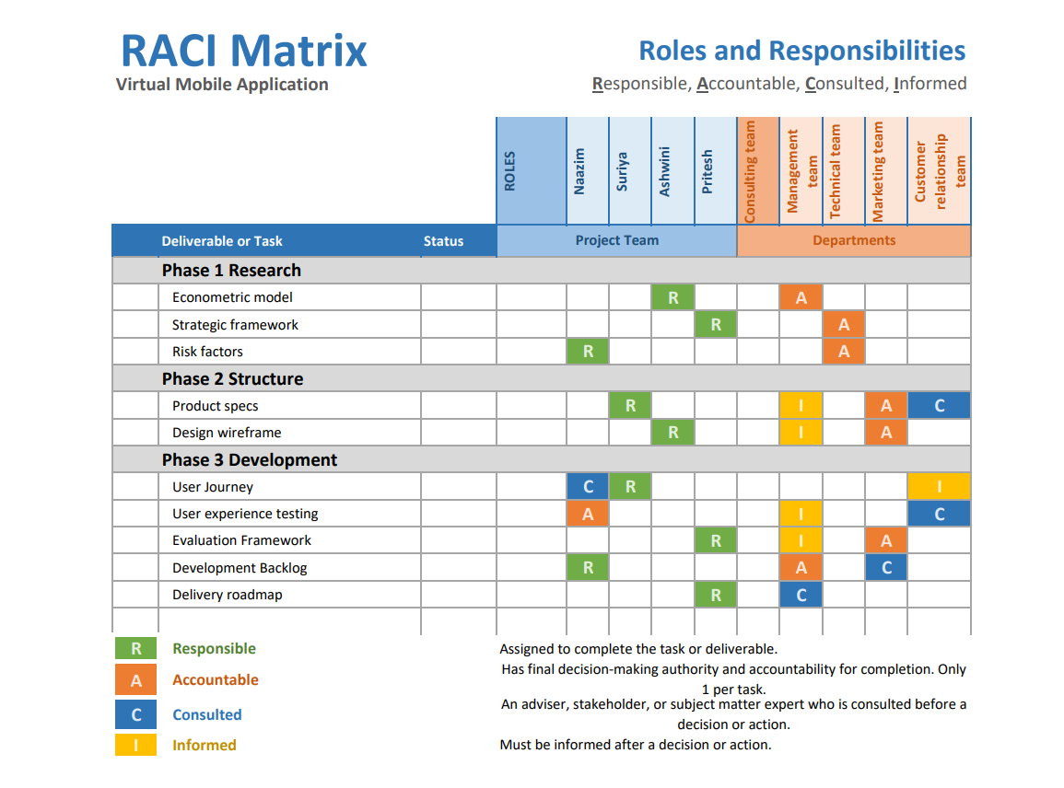

# Milestones List

**11.01.2022**

Project Name : Time2Go

Milestone Dates :

|  |  |  |
| --- | --- | --- |
| **Sl No** | **Task Description** | **Milestone Date** |
| 1 | Project Initiation | 20.01.2022 |
| 2 | Business case | 11.02.2022 |
| 3 | Formal approval of the Project plan | 14.02.2022 |
| 4 | Project Approval | 04.05.2022 |
| 5 | Project Close | 05.05.2022 |

**SMART Approach:**

Specific Measurable Achievable Realistic Timely goals.

1. **Project Initiation:**

This task is set as a milestone considering the importance to project initiating after identifying the team matrix and finding a scope in the project to freeze the timeline of the project in alignment with the client. This would give a clear road map for the Project team to plan concerned activities.

1. **Business case:**

This task is an important milestone as the data of the first planning is completed and the testing is reviewed with the Client to get necessary feedback for meeting customer expectation or product requirement.

1. **Formal approval of the Project plan:**

This task is crucial on the timeline where the Developer submits the project after testing, analysis stage is started and the process flow is reviewed, assigning tasks, timeline for the tasks, and the risks are identified to manage. After risk management the formal approval on project on14.02.2022 sent internally.

1. **Project Approval:**

This milestone is set for 04.05.2022 to remind the Client on the approval lead time to kick start the application online as per project requirement.

1. **Project Closure:**

Project closure is a crucial milestone to ensure the project is handed over to operations in specified time frame with financial closure and lessons learnt session.

**Milestone Chart:**

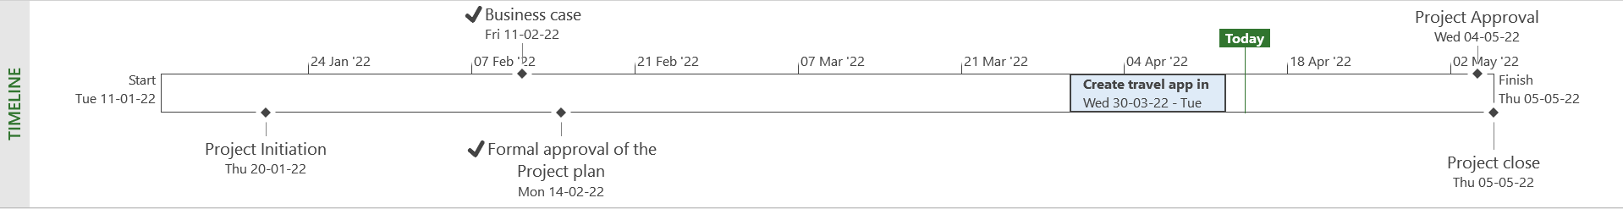

# Change Request Methodology

|  |  |  |  |
| --- | --- | --- | --- |
| Project Name | Time2go | Date | 07.02.2022 |
| Project Number | 001 | Requestor | Suriya Arivanandhan |
| Project Manager | Naazim Changani | Project Owner | Partners |

| Risk Identification/Analysis |
| --- |
| Legal Name change – Facebook conglomerate has recently changed their name to META and we have ongoing project with Facebook company and we have legal issues in changing the agreements with new replacement of new company name and to be signed by the clients. |
| Covid risks – “Covid” It’s been a trending word all over the world and vaccines, precautions are been prepared and taken care in most countries. Now, we can see the countries are relaxing their rules and slowing we are getting to normal situation so the markets are open to launch our product. |
| Metaverse development - There is been heavy rumors about metaverse that it’s not fully developed and lagging at software side. And we are dependent on them completely for building our mobile application and there is every chance of getting our project delayed. |
| Data privacy and security - Meta is already collecting huge amounts of user data through its existing virtual reality products, including people’s physical features like an estimate of their hand size, the digital objects and audio they create in VR, and information from third-party VR developers about users, so there is a chance of data blunders again from facebook side. |

| Change Request |
| --- |
| We are changing the legal name of the parent company from “Facebook” to “META” and the legal agreements are changed to META and the documents are signed and approved from the client end. |
| Governments are relaxing the rules and by following the protocols provides a space for product launch and gives huge scope for market success. |
| Due to continuing rumors, there may be a chance for delay in development of VR and AR using metaverse, so Time2go has decided to develop a own metaverse platform to create a virtual reality for places inside mobile application. This eliminates our dependency on META company and improves our demonstration in developing our own mobile application and creates good reputation from people. |
| Due to multiple data blunders from Facebook side, we have planned to create strong authentication for our mobile application. We are have decided to create strong passwords/PIN, regular cookies clearance policy and two/multi-factor authentication using authenticators to enter the mobile application, so that we can avoid unwanted data leaks and build a strong network with the customer. |

_____Naazim Changani_________________ __________07.02.2022____________

Approver’s Printed Name Date

____________Project Manager___________

Title

___ Naazim Changani __________________

Signature

# Quality Management Plan

The Project Quality Management Plan is one of the components of the project

that describes how the project team plans to meet the requirements of the quality of the

project. The team will develop and communicate policies of the quality to keep track

their project on objectives, and responsibilities and to satisfy the customer requirements

and quality of their expectations.

This documents also covers all the project’s deliverables such as business case or

project management plan, and processes like project scope management, risk

management etc.

## TOOLS, ENVIRONMENT, AND INTERFACE

|  |  |
| --- | --- |
| Tools | Description |
| Control Chart | Statistical process control |
| Pareto Chart | Access most frequently happening error |
| Brainstorming | Different views been shared for the same goal |

QUALITY PLANNING

It refers to the actions of the project team and its leader to participate in

establishing and conducting a process to fulfil the standards of project quality.

Furthermore, it can be divided into two parts; the Quality Assurance Plan and Quality

Control Plan.

3.1.1 Define Project Quality

There are three processes that are important to the quality of the project. First,

project quality management, including identifying project and product quality

requirements and documenting how the project meets quality requirements. The results

of this process include quality control plans, quality measurements, quality checks and

process improvement plans. Second, quality control consists of observation techniques

and activities used to meet quality requirements. Finally, project quality assurance, on

the other hand, involves ensuring that products are being produced in the right way

## QUALITY PLANNING

It refers to the actions of the project team and its leader to participate in

establishing and conducting a process to fulfil the standards of project quality.

Furthermore, it can be divided into two parts: the Quality Assurance Plan and Quality

Control Plan.

## Define Project Quality

There are three processes that are important to the quality of the project. First,

project quality management, including identifying project and product quality

requirements and documenting how the project meets quality requirements. The results

of this process include quality control plans, quality measurements, quality checks and

process improvement plans. Second, quality control consists of observation techniques

and activities used to meet quality requirements. Finally, project quality assurance, on

the other hand, involves ensuring that products are being produced in the right way

## Measure Project Quality

It is setting up Measure Project quality for guiding to greatest success project.

The project manager needs to think ahead about what each activity involves. the project

manager can measure project quality by looking at each of those activities, as they are

completed. But first, the project manager has to define Time2GO quality objectives. Follow

these steps below.

1. Divide your project into a careful work package that you can plan

appropriately.

2. Determine the quality objectives for each activity.

3. Decide how to measure the quality goals of each activity.

4. Specify the person who will approve the quality test and the quality test

results.

## QUALITY ASSURANCE

The quality requirements of a product or service will be met through the planned

and systematic activities implemented in the quality system. The quality assurance of the Time2GO project focuses on the process used to

develop the Time2GO product / service. To ensure quality, the iterative quality process is

used throughout the project lifecycle. This iterative process includes process metric

measurement, process data analysis, and process improvement.

The Time2GO Project Manager and the project team will conduct evaluations

throughout the project at planned intervals to ensure that all processes are implemented

and executed correctly. Key performance metrics for Time2GO product / service

development include quality, customer service quality, and rental service

quality for each phase of car sharing. The project tolerances established for these

metrics are the organizational standards for all other products / services for car sharing.

## Verification

The main activities involved in the verification process are:

**●** **Check-up:**

Quality Assurance Reviews are important in assessing the Internal Audit

Activity’s effectiveness and provide consultation to the senior

executives, the board and other stakeholders. These assessments offer

recommendations for the necessary updating requirements.

**●Process:**

A presentation is made, and comments are collected from the project

team and other stakeholders. Then, a report is generated by collecting

the issues captured and is distributed among the team members.

**● Scrutiny:**

Scrutiny is done by a knowledgeable person called a moderator, who is

not a team member or owner of the product. The moderator is assisted

by a recorder who capture all the defects found in the product. The

records are documented and presented to the Management and the

team members.

## Validation

The validation process is a product-oriented activity that evaluates the software

or the project result to ensure that it works properly and checks that the project meets

the user’s requirements. The processes for validating the project are following:

● Unit Testing: Unit testing is a level in which individual units or components of the

product is checked. The main purpose is to validate the each and every part of

the product to make it functional. It has one or less input that results in a single

outcome.

● Integration Testing: Integration testing is the second phase of the validation

process that is done after the unit testing, which is done by combining the

multiple components together and tested as a group to expose the failures or that

can occur in the overall parts of the product.

● System Testing: System testing is a testing of complete software product. It is a

series of various test which are full computer based. Two types of the system

testing is black box testing, white box testing

● Acceptance Testing: It is a formal description of the behaviour of the product. it is

also known as functional testing or customer testing that encourage the

collaboration between the organization and the clients.

## Improve Project Quality

There are five ways to improve Project Quality.

● Make a long-haul plan for quality enhancement, break it in too little

advances, and after that roll out improvements to accomplish objectives of

each progression.

● Give prevalent need of significant worth in every game plan and

frameworks. Remember, adjusting quality with time, cost or work can give

ephemeral points of interest anyway perpetually wreck what's to come

● Have frequent meetings with the consumers to know about quality of the

product. Examine why they like you, why they are enticing to go to your

rivals or what else they anticipate from you.

● As often as possible come close your item with your rivals and discover

where you are winning and where you are losing.

● Continuously search for conceivable outcomes to enhance your item and

administration. Precisely investigate each specialized/social advancement

and think how that can help you in your business

# Requirements Management Plan

Project Name: Time2go

## Overview of the Requirements Management Plan

This requirements management plan will define the process of gathering and documenting the Requirements for the time2go project including creating a platform for various agencies to access and complete the grant application online. This document will also establish what the process will be regarding gathering changes to the time2go project and how the changes will be documented, listed, and controlled.

**The scope of the Requirements Management Plan is as listed below:**

* Time2go Travel app will provide secure, simplified, and paperless process payments methods
* Time2go application will provide customers joyful and easy user experience
* Time2go online website will be able to advise applicants of the application status once the application has been completed.
* Time2go portal will be designed such that the text on the web pages should accommodate the needs of the visually impaired.

**Process:**

The project manager will be the main point of contact for gathering, documenting, and changing re- requirements and the process of doing so will include the following steps:

1. The project manager in collaboration with the product owner will conduct individual and group inter- views with stakeholders that will help define requirements for the project including various agencies, grant management advisory groups, selected end-users, and members of the governor's office as they are funding the project.
2. The product owner will define requirements and the project manager will document those requirements using the requirement management plan.
3. The project manager will track, document, and control changes to the project using the change management plan
4. The project manager will be responsible for tracking the progress of the project and making sure that the deadlines are being met, also maintaining the deliverables and high-end goals.
5. The project manager will be responsible for carrying out meetings as scheduled and tracking, documenting minutes of meetings and sharing with the team as necessary.
6. The project manager will also be responsible for providing regular updates regarding important milestones, and any changes to deadlines.

## Roles and Responsibilities:

**Project Manager: Nazim**

The project manager will conduct individual and group interviews with stakeholders that will help define requirements for the project including various agencies, grant management advisory groups, selected end-users, and members of the governor’s office as they are funding the project.

**Technical Project Manager: Aswini (Lead)**

The technical project manager will be responsible for delegating and tracking project deliverables for the software development team including any integration and consulting teams and tasks.

**Software Engineering Team: Pritesh (Lead)**

We will require 4 Software engineers who will be responsible for completing assigned tasks by the deadline, reporting any blockers to technical project managers, and resolving any technical issues as they arise. They won be required to report daily progress to the technical project manager.

**Testing Team: Suriya (Lead)**

We need 2 testing team members, who will be responsible for completing QA analysis and UAT items as they are completed and provide a list of passed and failed items to the Technical Project Manager. They will also be re- responsible for bringing any suggestions and ideas to improve the user experience.

## Rules and Procedures:

* All user requirements will directly come from the product owner and the project manager in collaboration will define project requirements and document them in the requirements management plan
* The project manager will work with the technical project manager to prioritize development for the development team, including deliverables and deadlines.
* The project manager will be responsible for tracking, reporting, and documenting any changes to the project and will be responsible for getting approvals for new requirements and deadline changes.

## Prioritizing Requirements:

The attributes of prioritizing and tracking requirements for the time2go project will be as follows:

1. Status: Approved, not approved, pending approval
2. Impact: High, Medium, Low
3. Criticality: High 7-10, Med 4-6, Low 1-3
4. Stability: Volatile, Neutral, Unlikely to Change
5. Efforts: Points 1(2Hrs or less), 2(2-4hrs), 4(4-8Hrs), and so on.

#### Requirements Management Tools

1. MS Excel: for tracking responses from interviews and defining requirements
2. MS Word: for documenting requirements management plan and change management
3. MS project: Managing development items, prioritizing requirements, and assigning tasks to developers
4. Outlook Email: to communicate meeting minutes that include requirements changes and approvals

#### Schedule:

|  |  |  |
| --- | --- | --- |
| **Sr.no** | **Particulars** | **Date** |
| **1** | Charter/scope document | 25th April 2022 |
| **2** | Role’s matrix | 1st May 2022 |
| **3** | Work breakdown structure | 5th May 2022 |
| **4** | List of issues documented | 10th May 2022 |
| **5** | To Be business process and user requirements | 15th May 2022 |
| **6** | Use and system testing | 15th August 2022 |
| **7** | Full implementation | 1st September 2022 |

#### Approval Requirements:

|  |  |  |
| --- | --- | --- |
| **Name** | **Title** | **Date** |
| Naazim Changani | Project Manager | 31st August 2022 |
| Aswini Chacko | Technical Project Manager | 15th July 2022 |
| Pritesh Bharadiya | Software Engineer lead | 31st July 2022 |
| Suriya Arivanadhana | Testing lead | 15th August 2022 |

# Risk Register

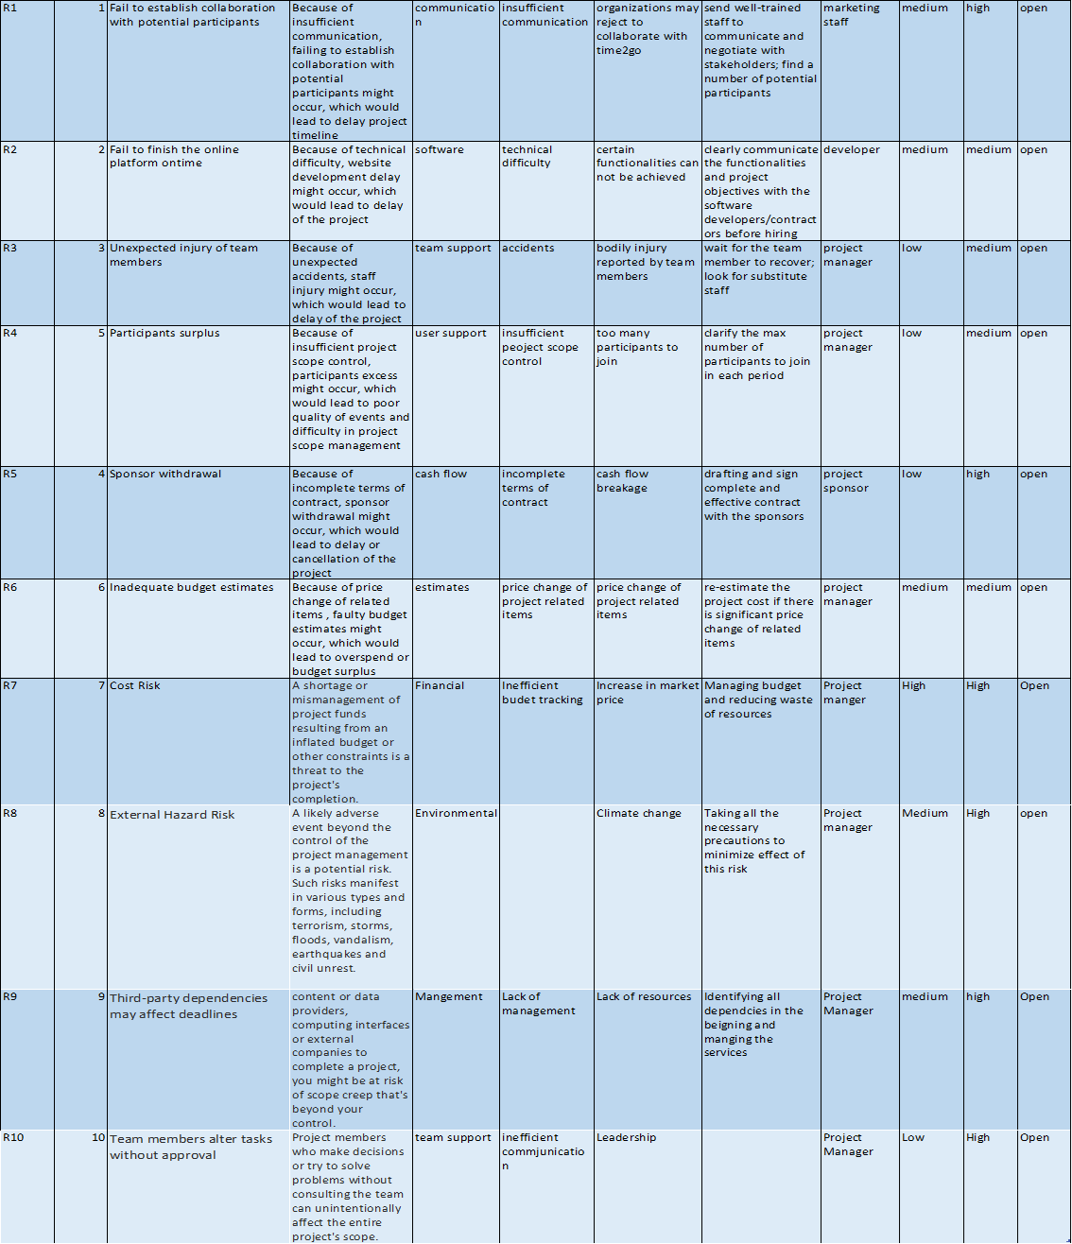

# Probability/impact matrix

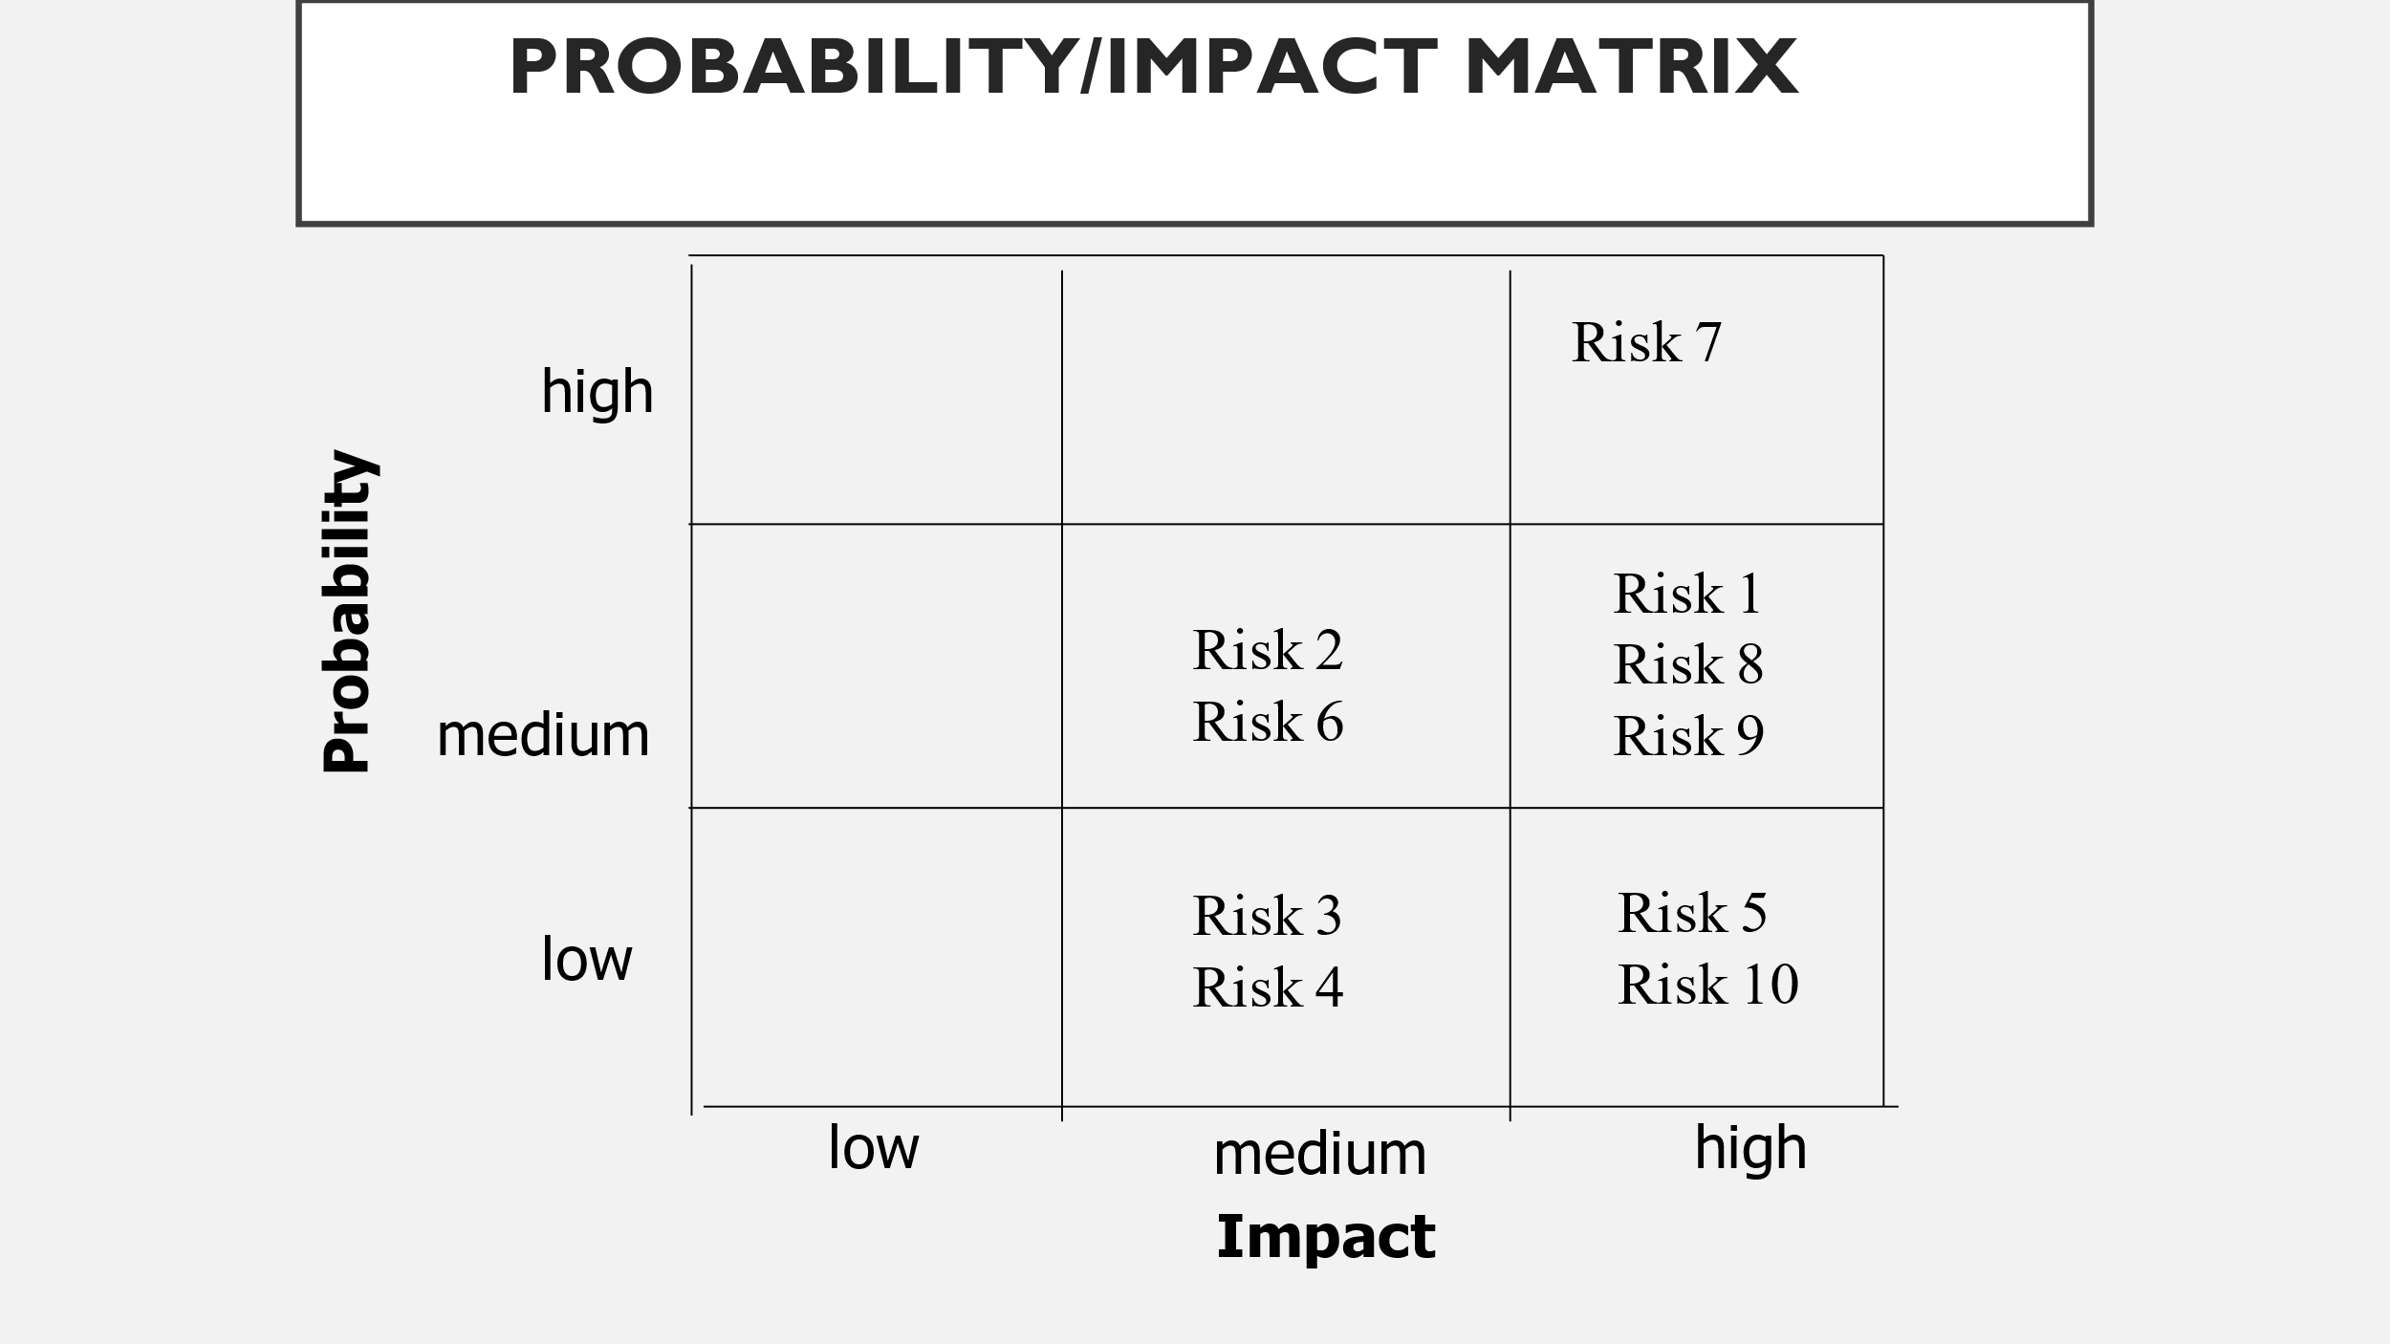

# Security Management Plan

The security management plan provides a framework that incorporates all elements of project security. Security risk is potential that a given threat will exploit vulnerabilities of an asset or group of assets.

Security management for Time2Go app is planned as below:

## Step 1: Categorizing the security challenges

Security responsibilities for Time2Go app includes:

• Monitoring and maintenance of firewalls: Mobile application must be tested by ITS security for the presence of vulnerabilities and coding weaknesses prior to deployment.

• Authentication and identity:

* Allow access to information resources only by authorized individuals.
* Ensure periodic review of membership in the community and review of their authorized access rights.
* Maintain effective access mechanisms through evolving technologies.

Metaverse faces two basic sets of security problems one that is familiar challenges technologists have been dealing with for decades and the other one is brand new ones built specifically for a metaverse setting. Most of the challenges in metaverse environment can be novel since it’s an emerging technology.

Security risk in the metaverse are familiar ones involving

* Fake identities
* The same NFT cannot be minted on multiple chains at the same time. Because it’s a unique element.
* Scammers target people looking for help via Discord channels. Discord channels are usually used by gamers and development studios.
* Phishing attacks that target the addresses of application.

The metaverse will be built on a distributed computing technology, blockchain, hence there are security advantages in this regard. The blockchain has increasingly been seen as an identity security solution. Blockchain is far more resistant to cyberattacks.

## Step 2: All the security threats should be assessed and controls are given for each one.

* Fake identities: It can be tackled by Multi Factor Authentication. Password and passcode sent for authentication is chosen as MFA.
* Discord channels: This attack can be avoided by improving message scanning settings.
* Phishing attacks: In metaverse it could be an avatar of a teller in a virtual bank lobby asking for your information. Users has to be cautious about this.

## Step 3: Supplement

* Security related system alerts and failures has to be there.
* Recording of the event in case of any security incident has to be maintained.
* Modification and unauthorized access have to prevented by implementing controls.
* The audit analysis of event logs, including IDS logs

## Step 4: Document

* Responding to cyber and information security incidents.
* Setting of policies, standards and guidelines for security of application.
* Document the change control Change request initiation and control

assessment of impact Control and documentation of changes, roles and responsibilities for documenting, testing, authorizing and implementing changes version control.

## Step 5: Assess

* All the security controls that are implemented has to verified to see if it works as expected. These controls are operating as intended, and are producing the desired outcome with respect to meeting the security requirements for the system.

## Step 6: Monitor

**Vulnerability check:** Security has to be checked on an annual basis there will be a formal review of the security program which addresses the objectives, scope, performance, and effectiveness of both the security management plan and the operational implementation of the plan.

Project Stakeholder Management Plan

The project stakeholder management plan is a component of the project management plan and

identifies the management strategies required to effectively engage stakeholders.

The level of details can vary based on the needs of the project.

Project Stakeholder Management Plan

The project stakeholder management plan is a component of the project management plan and

identifies the management strategies required to effectively engage stakeholders.

The level of details can vary based on the needs of the project.

# Stakeholder Management Plan

The project stakeholder management plan is a component of the project management plan and

identifies the management strategies required to effectively engage stakeholders.

The level of details can vary based on the needs of the project.

## Revisions and Distribution

|  |  |  |  |  |  |
| --- | --- | --- | --- | --- | --- |
| Revision | Release date | Distributed to* | | | |
|  |  | Client | Consultant | Main office | All project managers |
| Re.0 (draft) | 13/02/2022 | Judy Zheng | Pritesh | Aswini | Suriya, Aswini, Pritesh |
|  |  |  |  |  |  |
| Rev. 1 | 10/03/2022 | Jigar Patel | Pritesh | Aswini | Suriya, Aswini, Pritesh |
|  |  |  |  |  |  |
| Rev.2 (Final) | 12/04/2022 | John Smith | Pritesh | Aswini | Suriya, Aswini, Pritesh |
|  |  |  |  |  |  |
|  |  |  |  |  |  |
|  |  |  |  |  |  |

#### Amendments

The Project Stakeholder Management Plan from time to time may require updates. Any

amendment to this plan shall be informed to the change control board by use of the change

request form and approved by the project change control board prior to distribution. Only revised

parts of the plan will be distributed along with the approval and shall be accompanied by

instructions how to implement the changes.

The initial page numbering system (to be added upon initial approval) will be a normal continuous

numbering displayed in the lower right corner of each page. In the event that pages have to be

added, characters shall be added to the number. In case entire pages are deleted, the

corresponding page shall be replaced by a blank page stating “page removed”.

Each added/changed page shall have the revision number and date of approval displayed on the

bottom of the page

## Project Sponsor Approval

|  |  |  |
| --- | --- | --- |
| Prepared by: | Reviewed by: | Approved by Project Sponsor: |
| Toronto, 13/04/2022 | Toronto, 13/04/2022 | Toronto, 13/04/2022 |
| Naazim Changani | Suriya, Pritesh, Aswini  Project Managers | Allen Pan  Project Sponsor |

## Stakeholder Management Approach

Stakeholder analysis is the project manager's first step toward taking control of the project.

Stakeholders can be internal or external to the project's organization. Internal stakeholders could

affect or be impacted by a decision or outcome of our project such as the finance department,

accounting, project sponsor and project leadership team. External stakeholders are individuals or

groups outside the organization who could be impacted by our project or their decision could

affect the project such as vendors, customers and end-user.

Stakeholder analysis involves the development of stakeholder register, which contains the basic

information of project stakeholders who are the ones impact the project. Creating stakeholder

register can start with the project charter or business brief to learn more about the main decision-

makers and their expectations. Moreover, giving a name and role to each of them where possible.

Once stakeholder register has been done, knowing stakeholders’ true intentions by a personal

interview, and asking them a series of question. Besides, it’s time to determine the level of

influence they have over the project and categorize project stakeholders. In this step, assessment

matrix can be used for this task. Through stakeholder analysis, the Project manager is supposed to

know the influence the stakeholders have at any time and make the necessary adjustment.

## Stakeholder Identification

Identify Stakeholders is the process of identifying all individuals or organizations that can be positively or negatively impacted by the project, and documenting their influence, impact, interest, and involvement on project success. This is a key area in the project management process, as many projects fail due to a lack of complete stakeholder identification. Most projects will have a large number of stakeholders, and it is a project manager's job to identify stakeholders and understand the impact of the project on their specific business areas. In this respect, the project manager's job amounts to a relationship management function.

1. The first action is to start making a list of anyone in a decision-making or management role that is impacted by the project, such as the: sponsor, project manager, and primary customer and to interview them. As a result of these interviews others will be added to list to interview. We continue with this activity until you have added all potential stakeholders. To ensure that the list is as comprehensive as possible you should also seek input from those with specialized training or knowledge of the subject area such as: senior management, project managers who have worked on projects in the same area, experts in the business area, industry groups, and professional & technical associations.
2. In the next step we will create a list of requirements and expectations for each stakeholder. Each list should contain at least 1 expectation or 1 requirement accordingly.
3. Next, it may be useful to measure the influence and power level in the project. Influence level can use scale from 1 to 5, where 1 is no influence and 5 in extremely high influence. And for Power we’ll use scale that’ll include Low, Medium, and High marking.
4. The fourth step involves defining a role for each stakeholder. For example, each project should have a Project Manager or someone with experience in developing projects from scratch to manage people and process in project boundaries. In addition, it is important to identify owner of the project’s product. This list may include an individual, group, or organization that will accept the transfer of the project's product. Other roles may include consultant, decision maker, advocate, and so forth

As the project progresses, some stakeholders may increase or lose interest on our project, power and interest can be changed any time. Therefore, project manage need to make necessary adjustment in stakeholder engagement as needed.

#### The main level of stakeholders is: -

|  |  |  |  |
| --- | --- | --- | --- |
| Stakeholders | Power level | Interest level | Management Strategy |
|  |  |  |  |
| Customers | High | Low | Monitor |
| Company shareholders | High | High | Manage closely |
| Employers | Low | High | Monitor |
| Importers and exporters of materials | Low | High | Keep informed |
| Higher Authority | High | High | Manage closely |
| Low level of managers | Low | High | Keep informed |
| Governments | High | Low | Manage closely |
| Local communities | Low | Low | Monitor |

## Stakeholder register

|  |  |  |  |  |  |  |
| --- | --- | --- | --- | --- | --- | --- |
| Full name | Role in the project | Contact information | Requirements | Expectations | Influence level | Power level |
| Muhammad Shiblee | Sponsor | 4167365675, Muhammad＠gmail.com | Daily Report | On time with deliverable and the cost of project within the budget. | High | Supporter |
| Hardeep Singh | Project manager | 4168736253,  Hardeep＠  gmail.com | Reporting to sponsor | Control the process of the project and communicate among team members. | High | Supporter |
| Chuyun Yang | Team Lead | 4168476546,  Chuyun＠  gmail.com | Coordinating with the team and doing daily scrum | Assigning work to members and assisting to deal with issues. | Medium | Contributor |
| Wenxu Kang | Team Member | 4163454565,  Wenxu＠  gmail.com | Daily activities | Fulfil requirements and corporate with team. | Medium | Contributor |
| Vrushant Shah | Tester | 4163578686,  Vrushant＠  gmail.com | Daily activities | Fulfil requirements and corporate with team | Medium | Contributor |

#### Power/ Interest Grid

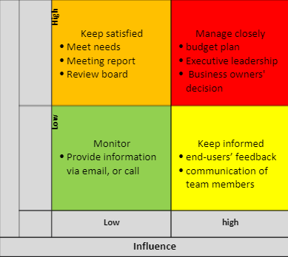

## Stakeholder Management Strategies

Manage closely

The sponsor of the project will be openly communicating to avoid any issues or political landmines.

Keep satisfied

The project team will be provided with sufficient resources and any barriers will be eliminated.

Keep informed

The open communication will be thoroughly maintained with the team leader and progress regarding project will be updated on regular basis and the power of Project Sponsor will be used whenever required.

Monitor

It will be very important to closely work and monitor with project team and stakeholders.

STAKEHOLDER MANAGEMENT STRATEGIES

Explain how you will effectively engage the stakeholders throughout the project life cycle, based

on their needs, interests, and potential impact on project success.

Manage closely

Keep close contact with sponsors, as their resources and decisions will have a crucial impact on the

project.

Keep satisfied

Efficient use of resources to meet needs.

Keep informed

The open communication will be thoroughly maintained with the team leader and progress regarding

the project will be updated on a regular basis

Monitor

Efficiently cooperate and monitor with project team and stakeholders.

## Control Stakeholder Engagement

It is very important to engage the Stakeholders for the success of the project. The main reason behind this is it greatly influence the implementation of the project. Effective communication should be maintained with the Stakeholders throughout the life cycle of the project and it is the responsibility of the Project manager.

The main aim of control stakeholder engagement involves the monitoring of the overall project and maintaining relationship with the stakeholder. This particular activity of project management requires inputs for the purpose of creating management plans. The inputs can be project documents, performance data, issues log, and the management plan. Adding more, using these inputs, changes and updating requests might be initiated.

The control stakeholder engagement observes that during the entire project, the stakeholder is committed.

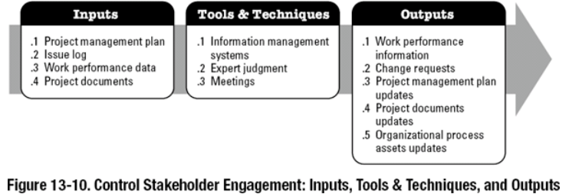

PURPOSE OF THE PROJECT QUALITY MANAGEMENT PLAN

The Project Quality Management Plan is one of the components of the project

that describes how the project team plans to meet the requirements of the quality of the

project. The team should develop and communicate policies of the quality to keep track

their project on objectives, and responsibilities and to satisfy the customer requirements

and quality of their expectations.

This documents also covers all the project’s deliverables such as business case or

project management plan, and processes like project scope management, risk

management etc.

2 PROJECT QUALITY MANAGEMENT OVERVIEW

2.1 ORGANIZATION, RESPONSIBILITIES, AND INTERFACES

Name Role Quality Responsibility

Liam Robert Project Manager Quality mentoring & coaching

Lucas Moore Team Lead Quality audits

Noah Harris Project Sponsor Final Approve Quality of project

Lily Caron Business Analyst Document Quality Progress

Ava Grant Project Team Member Quality amends

Emma Morin Project Team Member Quality amends

2.2 TOOLS, ENVIRONMENT, AND INTERFACES

Tool Description

Control Chart Statistical process control

Pareto Chart Access most frequently happening error

Brainstorming Different views been shared for the same goa

PURPOSE OF THE PROJECT QUALITY MANAGEMENT PLAN

The Project Quality Management Plan is one of the components of the project

that describes how the project team plans to meet the requirements of the quality of the

project. The team should develop and communicate policies of the quality to keep track

their project on objectives, and responsibilities and to satisfy the customer requirements

and quality of their expectations.

This documents also covers all the project’s deliverables such as business case or

project management plan, and processes like project scope management, risk

management etc.

2 PROJECT QUALITY MANAGEMENT OVERVIEW

2.1 ORGANIZATION, RESPONSIBILITIES, AND INTERFACES

Name Role Quality Responsibility

Liam Robert Project Manager Quality mentoring & coaching

Lucas Moore Team Lead Quality audits

Noah Harris Project Sponsor Final Approve Quality of project

Lily Caron Business Analyst Document Quality Progress

Ava Grant Project Team Member Quality amends

Emma Morin Project Team Member Quality amends

2.2 TOOLS, ENVIRONMENT, AND INTERFACES

Tool Description

Control Chart Statistical process control

Pareto Chart Access most frequently happening error

Brainstorming Different views been shared for the same goa

# Communication Management Plan

## Stakeholder communications requirements:

The five essential requirements that pertain to user usability and ease of access. These requirements were established to allow users from all over the world to navigate the app easily and quickly to obtain their desired information/services. These requirements are:

* 1. **User-friendly UI (User Interface):** The user interface must be designed to allow the users to easily navigate the app and find the templates or the information about various events organized by the team.
  2. **Accessibility Requirements:** The app must cater to a variety of people from various corners of the world. The app should allow users to translate the content according to any language of their choice. Moreover, the app must satisfy other accessibility requirements for specially-abled visitors.
  3. **Information Organization:** The App should have an organized page and layout to present material such as templates, documents, and training videos. This information should be easily acquired, so interested parties can "simply" find the material they are looking for.
  4. **User Feedback:** The app should allow users to register their feedback about the app, its services, and the quality and variety of templates offered. This feedback will provide user input necessary for the team to make modifications in the future.
  5. **ADA/GDPR Compliance**: The tools and software used to build the app must comply with the latest GDPR (General Data Protection Regulation) guidelines. the app should be perceivable to the senses, understandable and robust; meaning the app should work in all environments.

## Communications summary:

To provide updates and status reports, four communication methods have been established with the stakeholders. Communication will happen regularly, in the form of in-person meetings, as well as via e-mail.

|  |  |  |  |  |
| --- | --- | --- | --- | --- |
| **Stakeholders** | **Communications Name** | **Delivery Method/Format** | **Producer** | **Due/Frequency** |
| Naazim | Monthly Status Report | Meeting, & Hard Copy | Project Manager | First of the Month |
| Aswini | Monthly Status Report | Meeting, & Email | Technical Project manager | First of the Month |
| Pritesh | Training Plan | Email and meeting | Software Engineer | First of the Month |
| Suriya | Software Testing / ADA Compliance | Meeting | Software  Engineer | First of the Month |

## Comments/Guidelines:

* + The meetings should be conducted in a professional and time-bound manner. All the details regarding a meeting should be documented clearly and unambiguously for later review.
  + There should be a fixed and agreed-upon template for recording the meeting details, which should contain all the details like the date/time of the meeting, attending members, agenda of discussion, and action items.
  + The meeting minutes should be stored securely and be available to everybody present in the meeting, after the session is over, till the conclusion of the project.

## Escalation procedures for resolving issues:

Issues should be resolved at the lowest level possible. When they cannot be resolved, affected parties should alert their immediate supervisors of the issues. If an issue becomes critical to the project or becomes time-sensitive, the issue should be brought directly to the project manager. In case of escalation, the process would be:

1. Discussion to resolve the issue among all team members.

2. Official escalation e-mail to the team leader of the concerned team.

3. Meeting with the team lead about the issue(s).

4. If the issue(s) are still unsolved, the project manager must be notified.

## Revision procedures for this document:

Revisions to this document will be marked accordingly with a revision number and revision date in the top left of this document. The project manager should approve any Revisions to this plan.

Suppose all stakeholders and management concur on the alterations. In that case, the project manager can make and fill out other relevant paperwork and present them to the project sponsors for approval and review. The update is then publicized to all concerned departments and employees after it has been approved.

## Glossary of common terminology:

**Stakeholder**: A Stakeholder is any party with an interest in the successful completion of a project. More generally, the term refers to anyone who is affected by a project. (See also project stakeholder).